SVG: Scalable Vector Graphics

Anchor in the start by default:

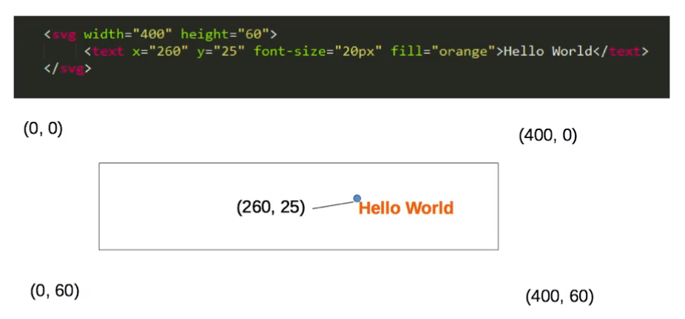

Anchor in the end:

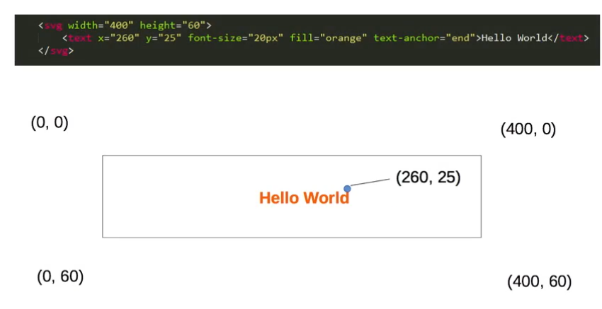

Anchor in the middle

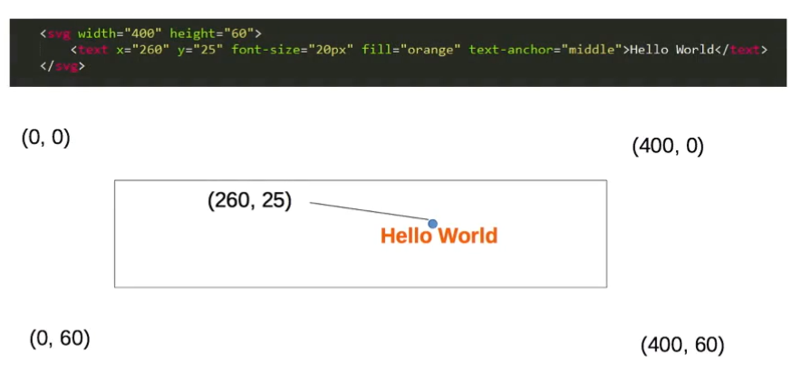

Rectangle

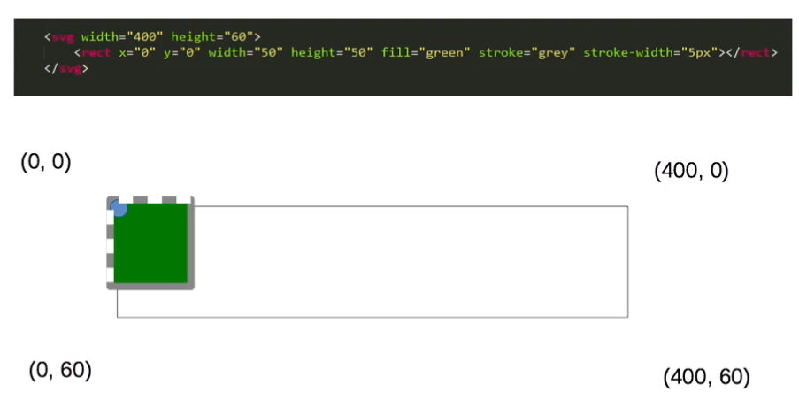

Cricle:

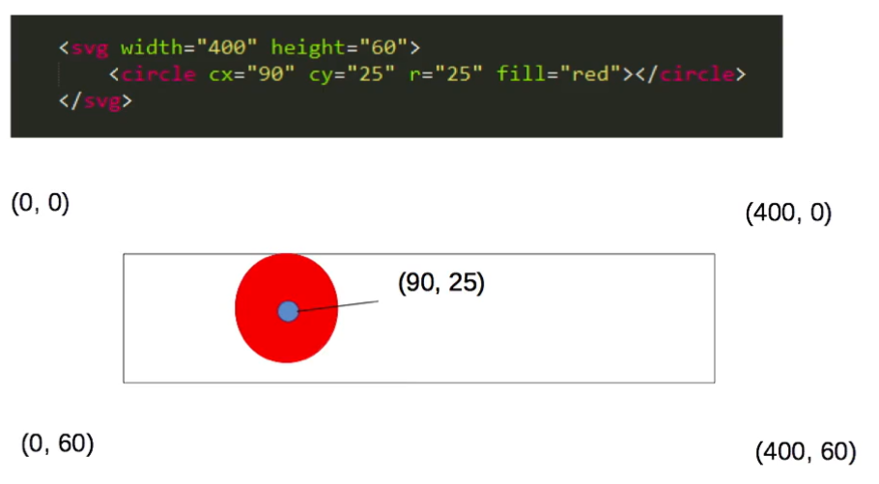

Ellipse:

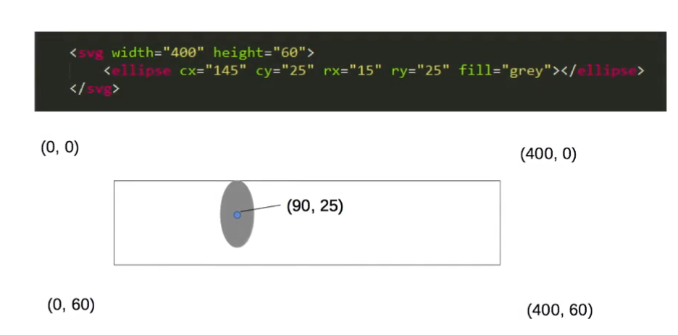

Line:

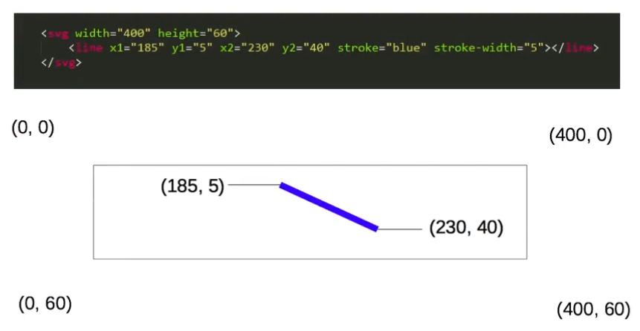

**Import D3:**

**$ npm install d3**

**import * as $D from 'd3'**

**$D.select("svg"): select an element**

**$D.select("svg").append("rect"): create a rectangle inside the element, and the context will be trimmed from svg to inside rect.**

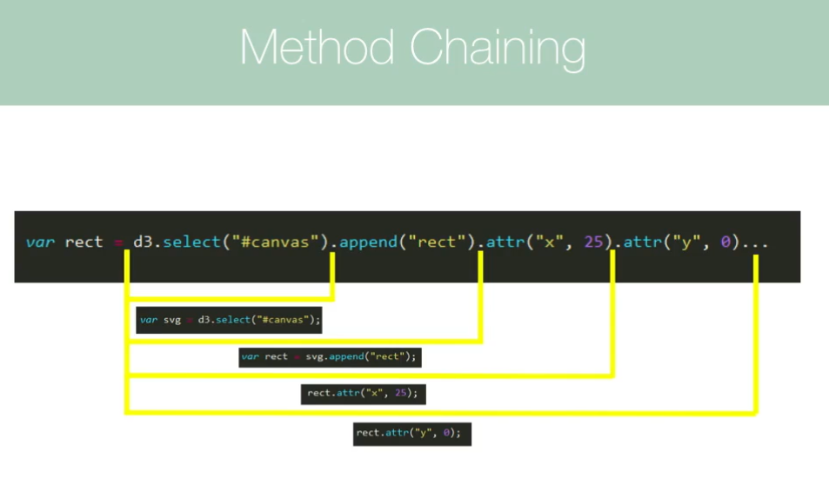

**Set attribute by mapping:**

**data = [25, 20, 10, 12, 15];**

**componentDidMount() {**

**const svg = $D**

**.select("#playGround")**

**.append("svg")**

**.attr("width", 400)**

**.attr("height", 400);**

**// create a shell for adding circle, which has data.length place to insert**

**// The shell cannot be a const, otherwise the append will not work**

**let circles = svg.selectAll("circle").data(this.data);**

**// enter the shell and insert data.length circles**

**circles**

**.enter()**

**.append("circle")**

**.attr("cx", (d, index) => {**

**return index * 50 + d;**

**})**

**.attr("cy", (d, index) => {**

**return index * d + d;**

**})**

**.attr("r", (d, index) => {**

**return d;**

**})**

**.attr("fill", "red");**